Update Ikea zigbee devices from Deconz

I’m having a mix of difference zigbee devices on my Deconz zigbee gateway. A downside with that config, is that your zigbee device doesn’t get updated with new firmware. But you can actually update Ikea devices from deconz. Hue is not possible, as far as I know, because Hue is using encrypted firmware. I currently investigation if it is possible to update Lidl devices. But at this time I don’t know if that is possible. **This guide is for you that have Deconz running on a Raspberry Pi.**  
Let get started with the guide.

Some usefull links:

[Ikea firmware download](http://fw.ota.homesmart.ikea.net/feed/version_info.json)  
[Ikea firmware release notes](https://ww8.ikea.com/ikeahomesmart/releasenotes/releasenotes.html)  
[Deconz Ikea download script](https://github.com/dresden-elektronik/deconz-rest-plugin/blob/master/ikea-ota-download.py)

Enable OTA

Start by enabling OTA updates. This is done in the “Wireless light control” web interface. NOT the normal Deconz web interface. The url is:  
http://DECONZ_IP/login.html  
Login:  
User: delight  
Password: YOUR DECONZ PASSWORD

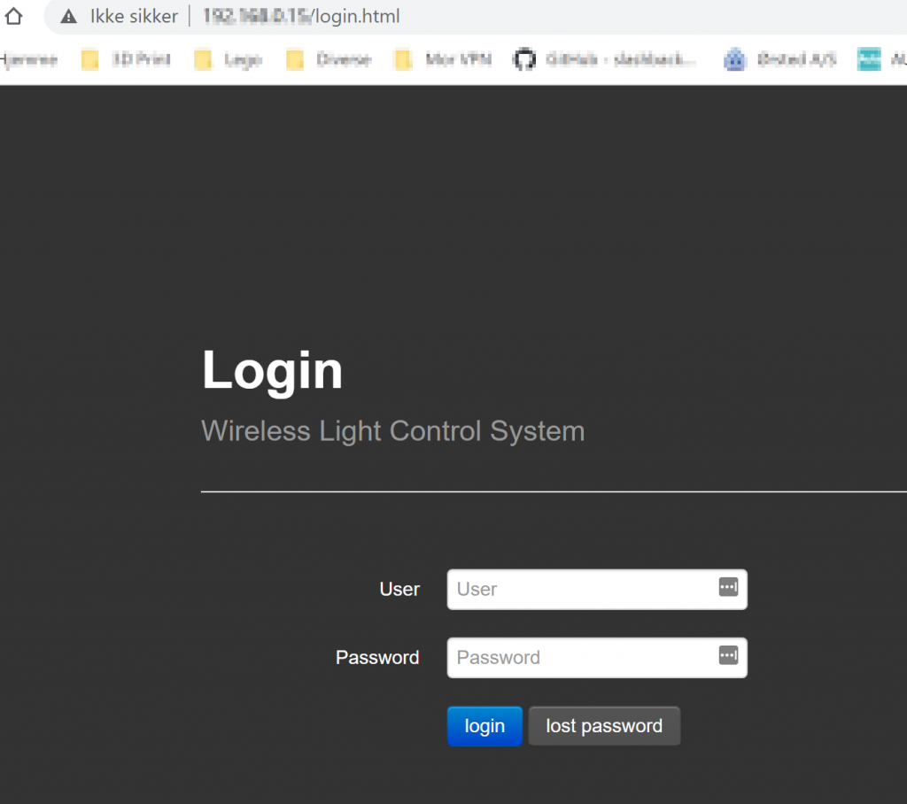

Click **Menu -> Settings**

Click **Show Advanced Settings**

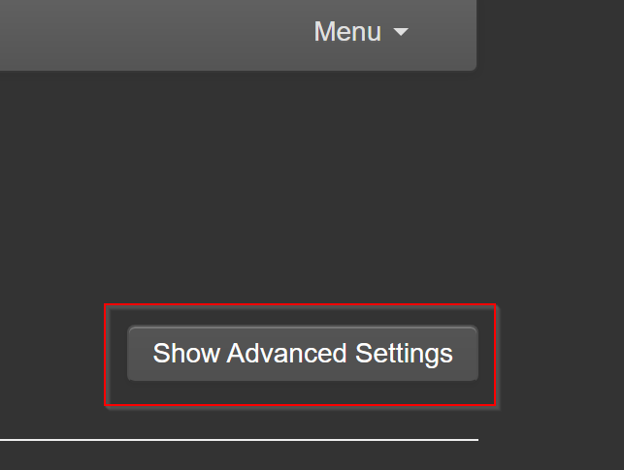

Go to the **Advanced Network Setting** section. Enable **OTAU Server** and click **Apply**.

Go to **Menu** -> **Logout**.

Download Ikea firmware.

You need a VNC viewer to connect to your Raspberry PI. I use realVNC witch is free. But you can use one of your own choice.  
Open VNC and enter the Deconz IP address and connect. In Realvnc you have the option to save the connection.

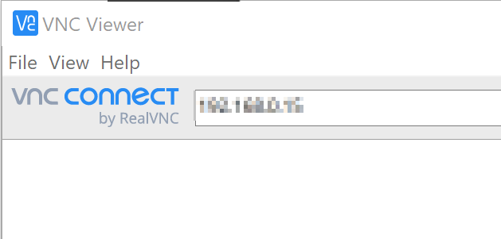

Click **Continue** to the Identity Check.

Enter **username** and **password** and click **OK**  
Username: pi  
PAssword: YOUR DECONZ PASSWORD

**Minimize** Deconz

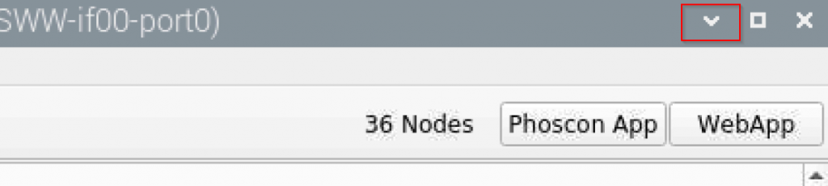

**Right click on the desktop** -> **New File**

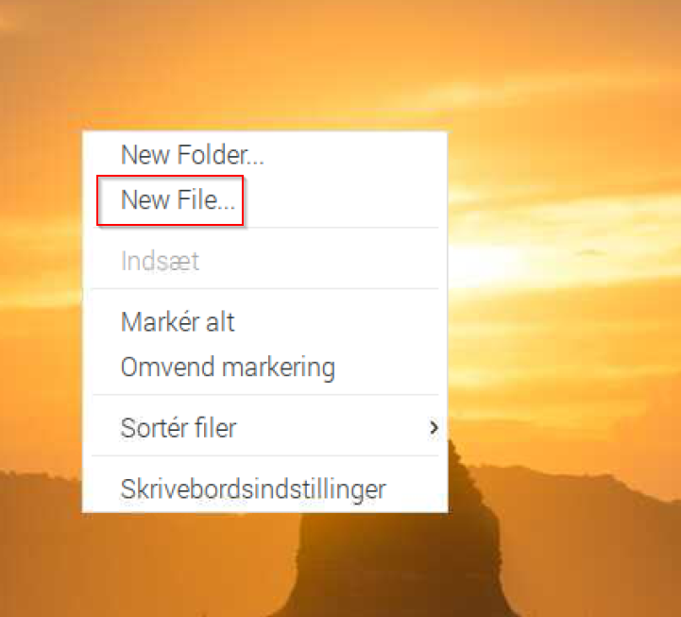

Call it ex. “Ikea_Download_Firmware.txt” -> Click **O.K.**

Open the browser -> go to this this url:  
https://github.com/dresden-elektronik/deconz-rest-plugin/blob/master/ikea-ota-download.py

Click **Raw**

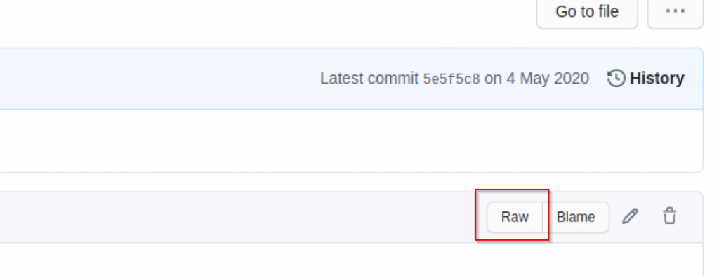

**Mark the txt** -> **copy it**.

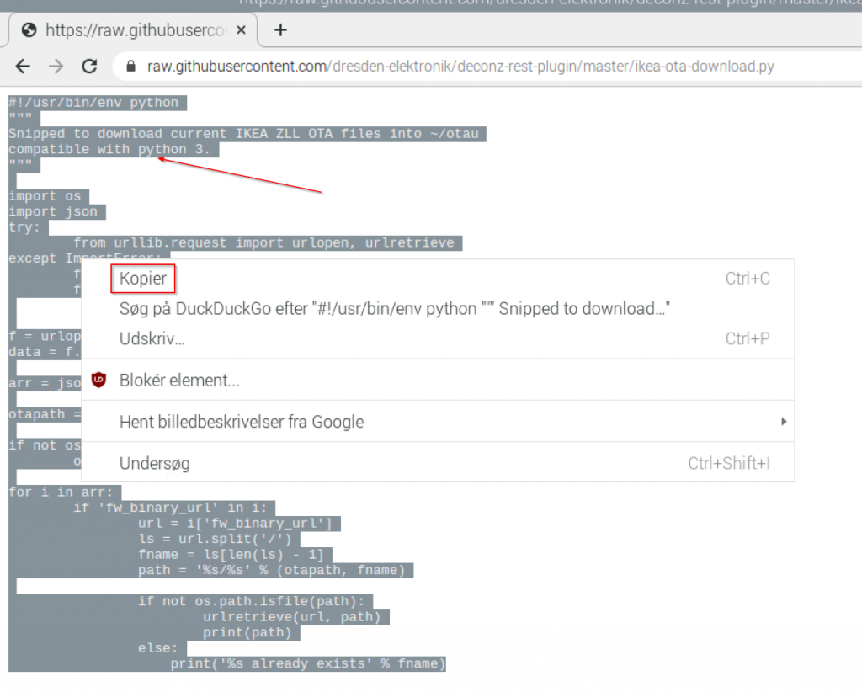

Open “**Ikea_Download_Firmware.txt**” located on the desktop.

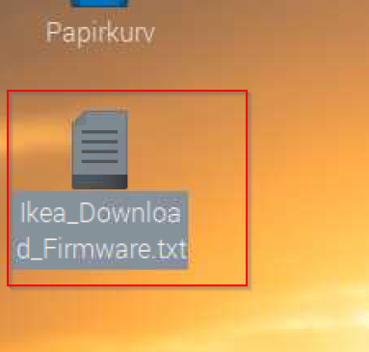

**Paste the text**that you have copied from the web page into the “**Ikea_Download_Firmware.txt**” -> **Save the file**.

Rename the file to .py instead of .txt: “**Ikea_Download_Firmware.py**” -> Click **O.K.**

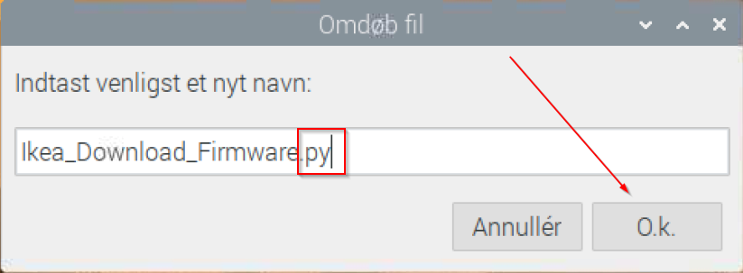

Open “terminal”

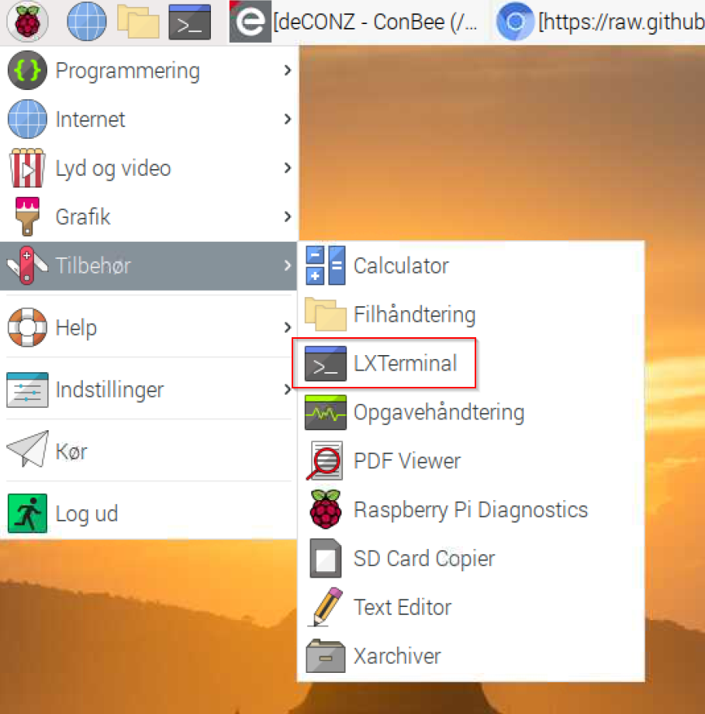

**Type “cd Desktop”** -> **Enter**. Linux is case sensitive, so make sure the you have a capital D in Desktop.

**Type “python Ikea_Download_Firmware.py”** -> **Enter**. Linux is case sensitive, so make sure the you have a capital D in Desktop.



All Ikea firmware update is now download. They are save in the OTAU folder under the profile. **Don’t change this path or folder name!**

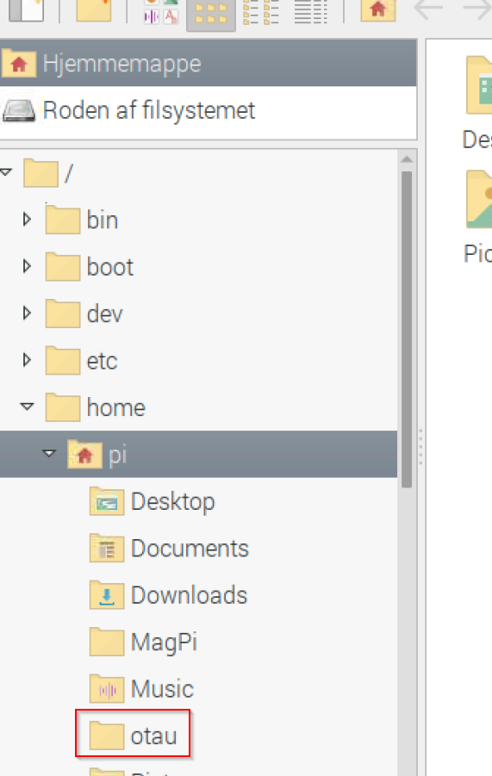

Updating Ikea devices

Close “Deconz”

Start “Deconz” again

Enable the **“STD OTAU Plugin”** plugin.

You can see that “**OTAU enabled**” is checked.

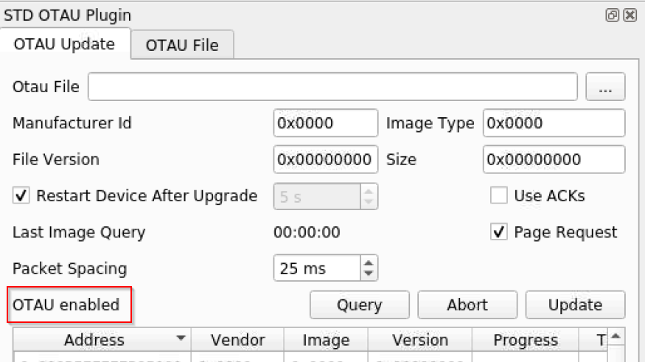

C**lick on a Ikea light** in the right handside -> Click **Query** in the left handsite. Deconz til now get information about the light.

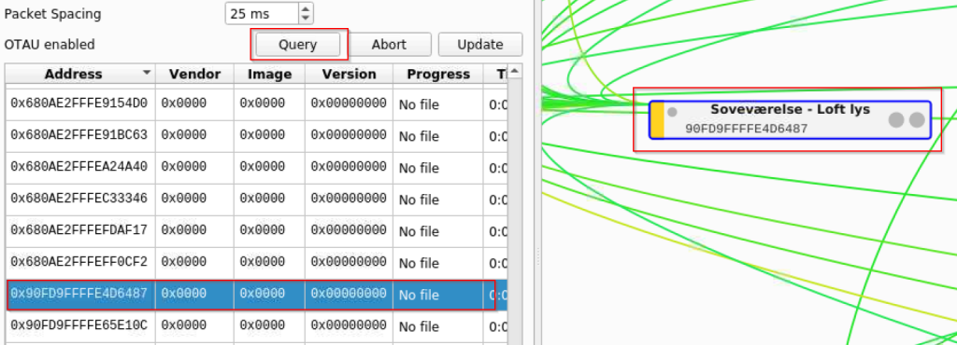

If a firmware is newer (We download these in an earlier step), than the one that the device is using. Then Deconz will automatically start the upgrade process. You don’t have to choose anything. Deconz will handle that for you. After you hit **Query,** then all the information will also be added to Deconz. In **Version** you can see the current version and in **Time** you can see how long the update have been running. It will take between 15-20 minutes to upgrade a light bulb. After the upgrade the light bulb will reboot. So if you light is on, then it will turn off and then on again after some seconds.

That it. Please remember that once in a while you have to run the script again to get new firmware updates if Ikea have published them. Maybe you should set up a scheduled task that run every month or so.